**OLYMPICS :**

The evolution of the Olympic Movement during the 20th and 21st centuries has resulted in several changes to the Olympic Games. Some of these adjustments include the creation of the Winter Olympic Games for snow and ice sports, the Paralympic Games for athletes with a disability, the Youth Olympic Games for athletes aged 14 to 18, the five Continental games (Pan American, African, Asian, European, and Pacific), and the World Games for sports that are not contested in the Olympic Games. The Deaflympics and Special Olympics are also endorsed by the IOC. The IOC has had to adapt to a variety of economic, political, and technological advancements. As a result, the Olympics has shifted away from pure amateurism, as envisioned by Coubertin, to allowing participation of professional athletes. The growing importance of mass media created the issue of corporate sponsorship and commercialisation of the Games. World wars led to the cancellation of the 1916, 1940, and 1944 Games. Large boycotts during the Cold War limited participation in the 1980 and 1984 Games. The latter, however, attracted 140 National Olympic Committees, which was a record at the time.The total number of events in the Olympics is 339 in 33 sports. And for every event there are winners. Therefore various data is generated. So, by using Cognos Analytics we will analyze this data and find the insights.

**Problems Faces on Olympics :**

* **BUDGET :**

The bill for the Tokyo Olympics and Paralympics is expected to be [1.64 trillion yen](https://myinfo.tokyo2020.org/general-search/facts-and-stats-tokyo-2020-olympic-and-paralympic-games) ($15 billion), 22% higher than it was before the Games were delayed in 2020. That figure is also twice as much as the 800 billion yen estimate Tokyo submitted in its bid to host the games.

The bill, which will have to be fully funded after the Games end, is split three ways among the Tokyo 2020 organisers, Tokyo Metropolitan.government and Japan’s central government. The host city is responsible for the biggest chunk.

* TICKETS :

Before the decision in 2020 to delay the Games, 4.48 million tickets had been sold, which had been expected to generate [90 billion yen](https://jp.reuters.com/article/uk-olympics-2020-tickets-idAFKCN2DX139) ($816 million) in revenue. That figure will now be close to zero. The Tokyo organising committee is responsible for ticket sales, and after using up much of its event cancellation insurance policy, is [unlikely to get much of a pay-out](https://www.reuters.com/business/finance/local-olympics-organisers-face-uninsured-loss-spectator-ban-sources-2021-07-12) on lost ticket sales, according to insurance industry sources.

* SPONSORS :

While they would normally look to recoup that outlay from sales linked to interest in the Olympics, some big corporate names worried about the potential damage to their brands as public opinion in Japan turned against the Games.

Toyota chose [not to run](https://www.reuters.com/lifestyle/sports/two-thirds-japanese-doubt-pandemic-olympics-can-be-safe-says-poll-2021-07-19) Olympics-related TV commercials in Japan. Others, including Panasonic, had to scale back client entertainment plans at Games venues after spectators were banned.

* ECONOMY :

A key reason for Japan to host the Olympics was to boost tourism, which in the decade before the pandemic halted most international travel had quadrupled to more than 30 million visitors a year. In 2019 they spent nearly [4.81 trillion yen](https://www.reuters.com/article/us-olympics-2020-cancellation-economy-fa-idUSKBN20Q0MD) ($43.6 billion) in Japan at hotels, restaurants, shops and for other services.

A normal Olympics could have added 0.33% to gross domestic product (GDP), or around 1.8 trillion yen, Nomura Research Institute estimated before the Games.Instead, Japan's government has to convince an already sceptical public that hosting the Olympics was the right decision even without the economic windfall.

**Literature Survey on Olympics :**

The Olympic sports bring together a large and diverse range of human abilities that extend far beyond the Olympic motto, “*Citius—Altius—Fortius*” and outstanding genetic, physical, technical and mental skills are required to reach an Olympic podium. It is therefore not surprising that behind each athlete is an interdisciplinary team of experts/scientists . Elite sports performance has long been a fascinating field of research for scientists. The 1922 Nobel Prize in Physiology or Medicine, awarded to Sir A. V. Hill and his work on the best middle-distance runners of his time, provides a perfect example of ground-breaking research originating from related questions. Over the last two decades, the “sport sciences” field has massively expanded, as evidenced by the continuously growing number of journa. The original definition of sport sciences as “*the study and application of scientific principles and techniques to improve sporting performance*”has become too narrow, and researchers in different scientific fields are producing an enormous body of research related to exercise and sports. However, to our knowledge, there has been no comprehensive analysis of the “sport sciences” field and no comparison of the sport-specific scientific literature across all Olympic sports. Currently available bibliometric analyses are limited to the most cited articles in sport and exercise medicine or specifically concern a single sport, such as football or a specific scientific field.In 1992, the summer (Barcelona) and winter (Albertville) Olympic games took place for the last time in the same year. Due to the COVID-19 pandemic, the two games (Tokyo 2020 Summer Olympic Games between 23 July and 8 August 2021 and Beijing 2022 Winter Olympics between 4 and 20 February 2022) will now be organized within a 7-month timeframe. This may be an occasion to review the science across all summer and winter Olympic sports.

The data were obtained by a search in PubMed followed by a search conducted in Web of Science (Clarivate Analytics, USA). First, we selected 116 “sport sciences” journals, including 85 journals of the “*sport sciences*” category in the Incites journal citations report (Clarivate Analytics, USA); then, we expanded the search to other journals with “exercise” or “sport” in the title. Second, we chose to limit the analysis to sports that are currently in the Olympic programme for Tokyo 2020 and Beijing 2022. This list of sports does not contain sports to be included in the Paris 2024 Olympic Games or sports eliminated from the Olympic programme. We split some sports into subdisciplines.

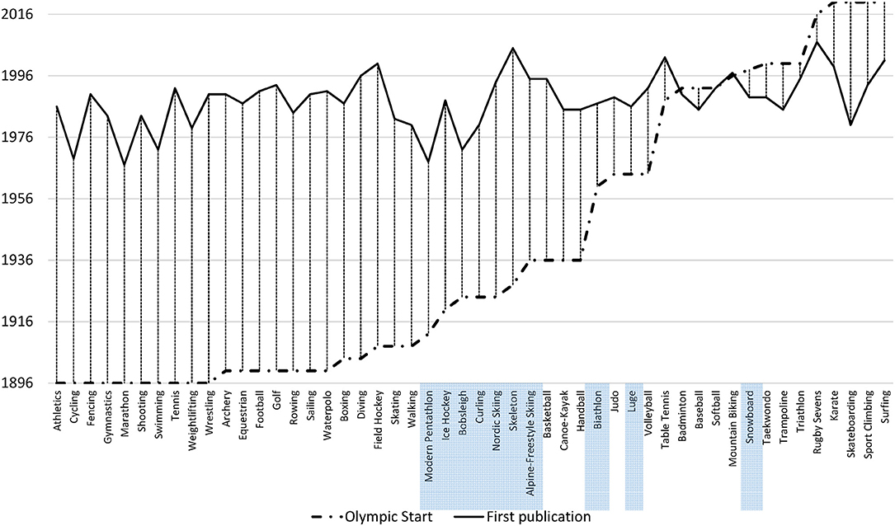

* + 1. 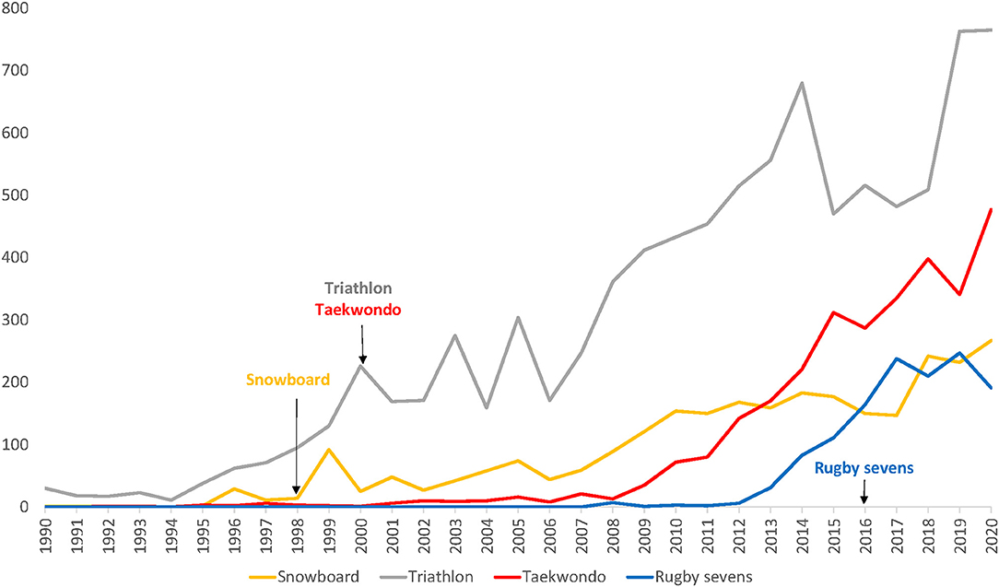Dates of the Olympic debut and of first publication across all summer and winter Olympic sports. Winter sports are highlighted.
    2. Number of citations per year (y-axis) in four “recent” (i.e., debut at 1998 or later) Olympic sports. The date of the Olympic debut is marked by an arrow.

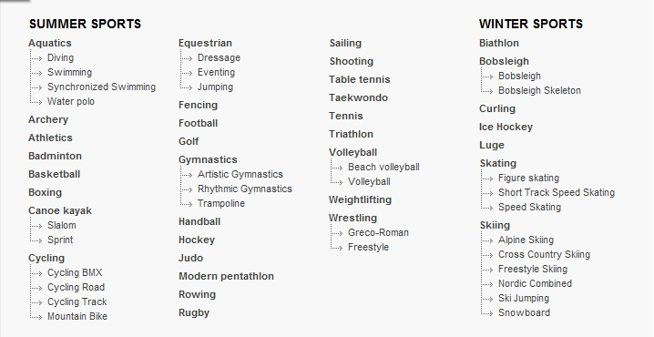

* + 1. Summer and Winter Olympic Sports List

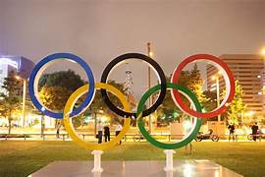

iv) OLYMPIC SPORTS